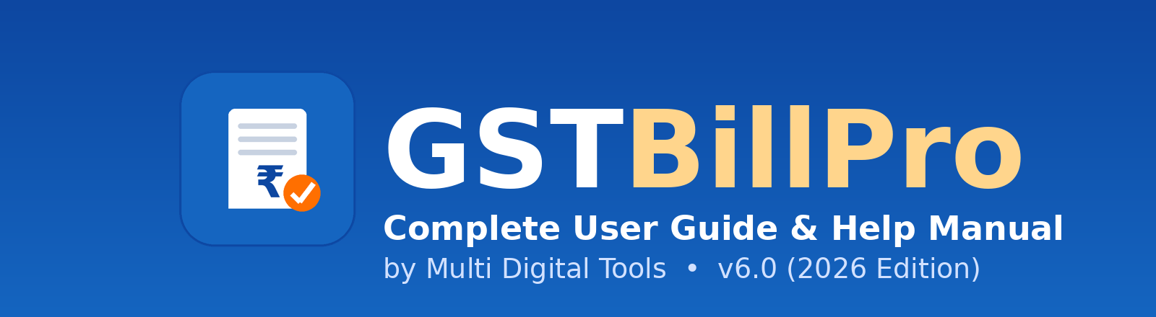

GSTBillPro
Complete User Guide & Help Manual
GST Billing, Inventory & Accounting — Point of Sale System
Step-by-step, from first launch to daily billing
Version 6.0 • 2026 Edition
by Multi Digital Tools
https://multidigitaltools.com/products/gstbill
support@multidigitaltools.com

Welcome
GSTBillPro is an all-in-one billing solution for Indian businesses. It handles sales & POS, purchases, inventory, GST (CGST/SGST/IGST/CESS), accounting and reports. This help manual walks you through the complete journey with real screenshots from the software.
SHORTCUTS: From the Dashboard, press F1–F8 to open the most-used screens instantly — F1 Sale, F2 Purchase, F3 Receipt, F4 Payment, F5 Customer, F6 Supplier, F7 Product, F8 Expense.

Contents
- 1. Starting the software
- 2. Logging in
- 3. The Dashboard
- 4. Add a Product
- 5. Add a Customer
- 6. Add a Supplier
- 7. Make a Sale (POS)
- 8. Record a Purchase
- 9. Receive a Payment (Receipt)
- 10. Make a Payment
- 11. Record an Expense
- 12. Reports & GST Returns

Getting started
1 Starting the software
Double-click the GSTBillPro icon. The startup screen loads the program modules and checks your licence.
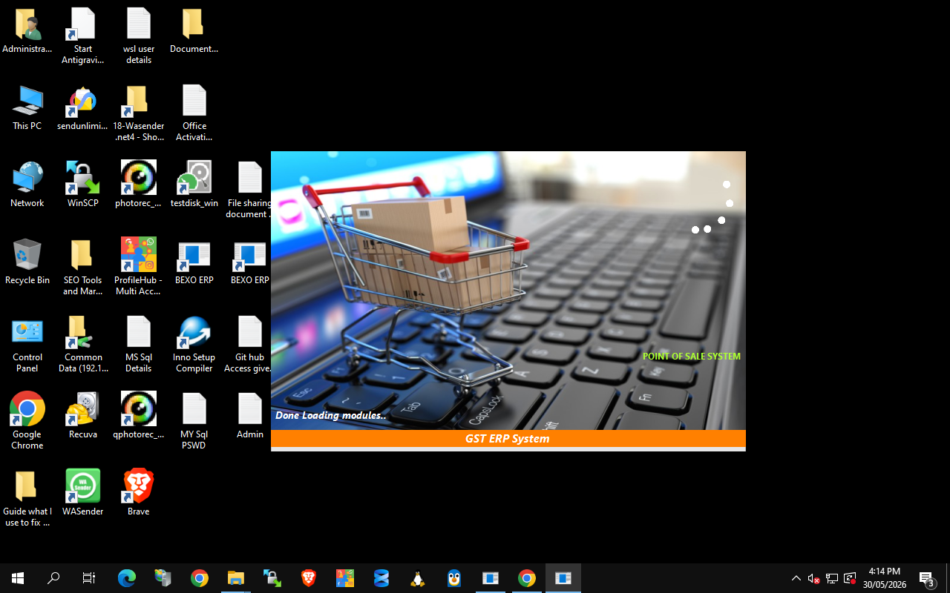
The GSTBillPro startup / loading screen
FIRST RUN: On a new install you'll be guided to configure the SQL Server connection and create your company. After that, the app goes straight to the login screen each time.
2 Logging in
Choose your Company, type your User Name and Password, then click Login.
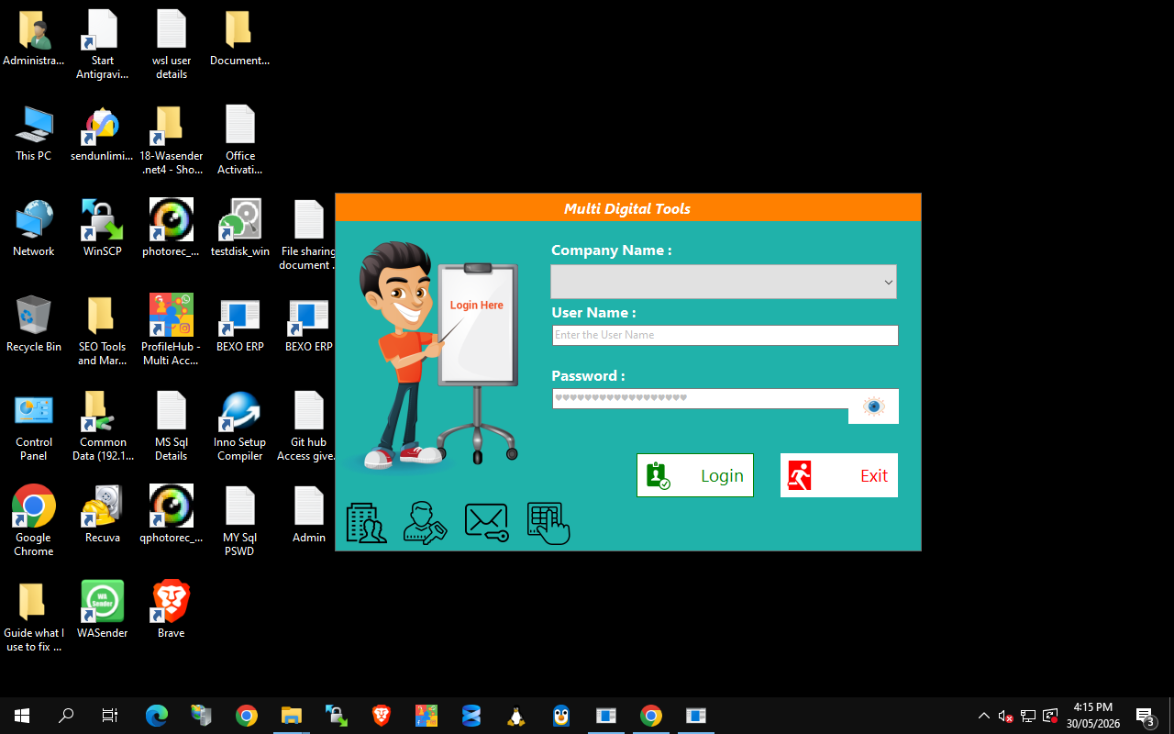
Login — select company, enter your credentials
- Company Name — pick the business you want to work in (multiple companies supported).
- User Name / Password — staff login. Roles: Admin, Sales Person, Inventory Manager — each sees only what's allowed.
DEFAULT ADMIN: user 'admin' / password 'admin'. Change it from Administrator → Change Password after first login.
3 The Dashboard
The Dashboard is your home base. The left menu opens every module; the coloured tiles are one-click shortcuts; the top strip shows today's totals at a glance.
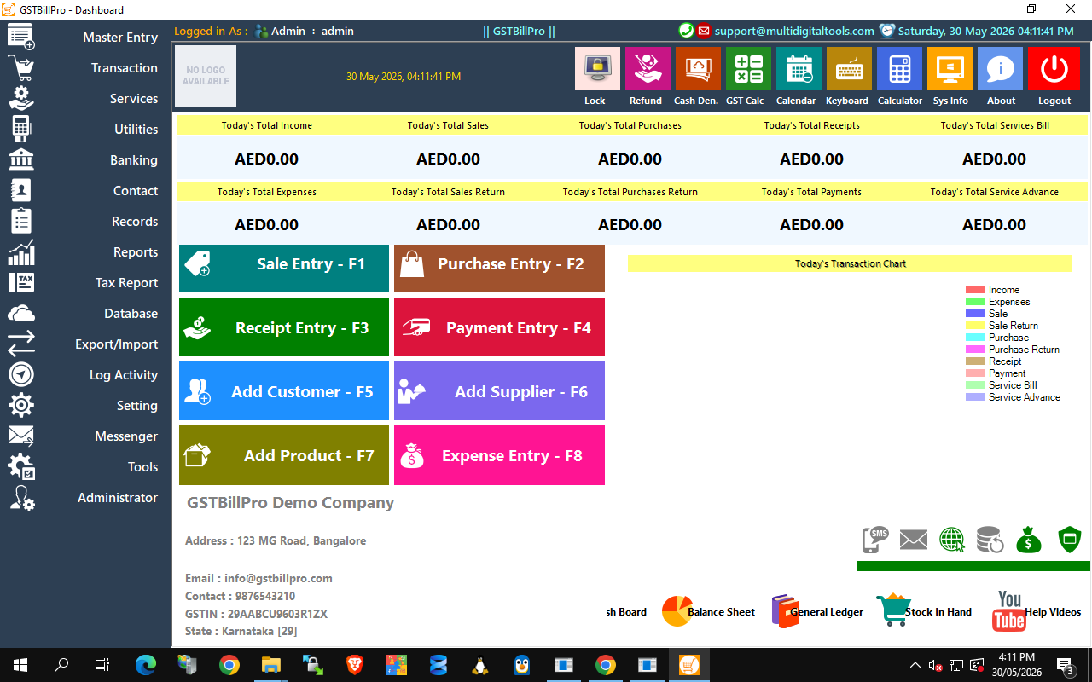
The main Dashboard — live totals, quick-action tiles and the module menu
- Today's totals — Income, Sales, Purchases, Receipts, Expenses, Returns and Payments, updated live.
- Quick keys — F1 Sale, F2 Purchase, F3 Receipt, F4 Payment, F5 Customer, F6 Supplier, F7 Product, F8 Expense.
- Left menu — Master Entry, Transaction, Banking, Records, Reports, Tax Report, Database, Settings and more.

Setting up your master data
4 Add a Product (press F7)
Create the items you sell. GSTBillPro auto-generates a product code, a barcode and a QR code.
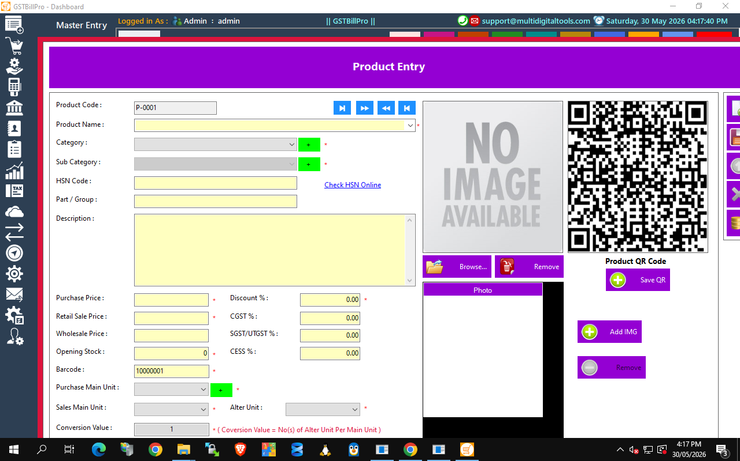
Product Entry — full GST fields, barcode and auto QR code
- Enter the name, pick/add Category & Sub-category (green + adds new), set HSN code, prices, opening stock and GST rates (CGST/SGST/CESS), then choose units. Click Save.
TIP: Use 'Check HSN Online' to find the correct HSN code and GST rate for your product.
5 Add a Customer (press F5)
Store your customers once and reuse them on every invoice — all GST-ready fields included.
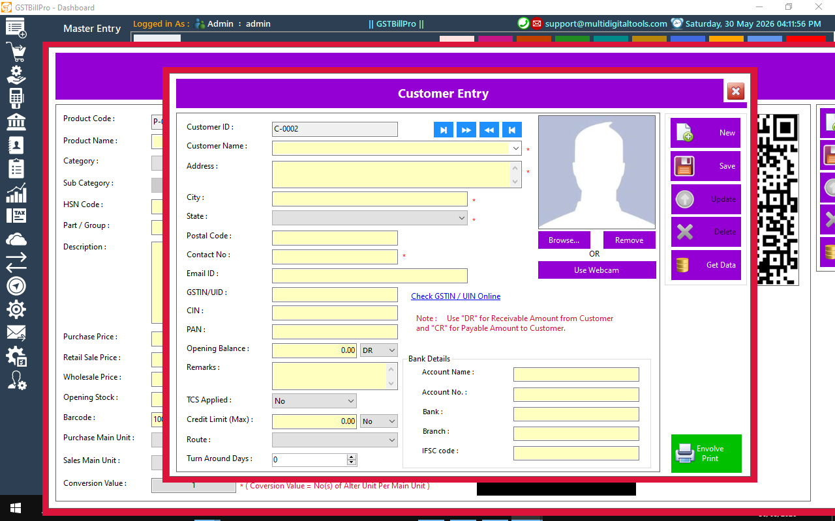
Customer Entry — contact, GSTIN, credit limit, bank details and photo
- Capture name, address, contact and email; add GSTIN/UIN, PAN, CIN (validate with 'Check GSTIN Online'); set opening balance (DR/CR), credit limit, bank details and a photo.
6 Add a Supplier (press F6)
Record the vendors you buy from. The form mirrors the Customer screen, so it's instantly familiar.
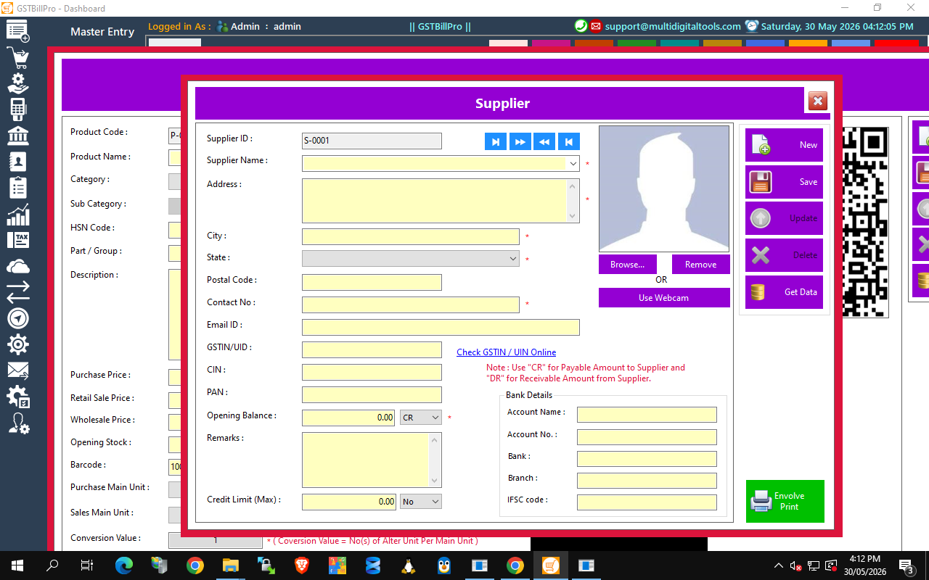
Supplier Entry — full vendor master with GST and bank details

Daily transactions
7 Make a Sale — Point of Sale (press F1)
This is the heart of the system — bill a customer in seconds with full GST calculation.
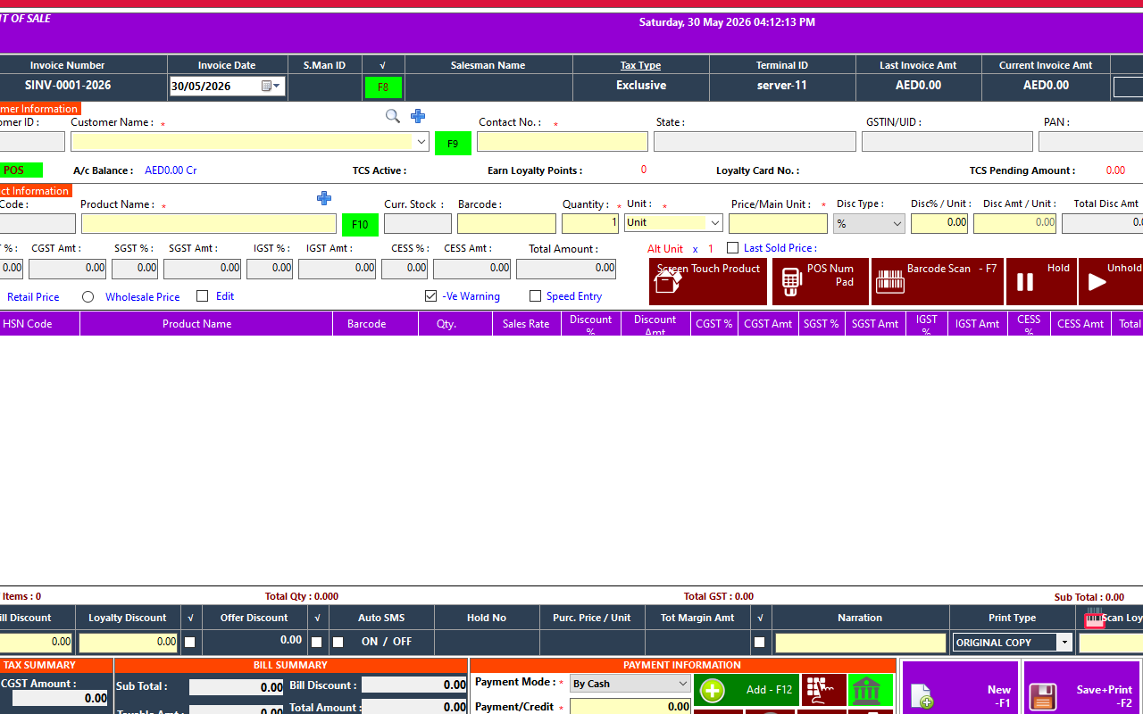
Point of Sale — barcode scanning, live GST, payment and print
- Pick the customer, scan a barcode or type the product (price, stock & GST auto-fill).
- Set quantity and discount — CGST/SGST/IGST/CESS calculate live per line.
- Enter payment (F12), then Save + Print (F2). Stock and ledgers update automatically.
SPEED TOOLS: Screen-Touch Product grid, POS Num-Pad, Barcode Scan (F7), and Hold/Unhold to park a bill and serve the next customer.
8 Record a Purchase (press F2)
Enter stock bought from suppliers. Inventory goes up; supplier ledger and GST input are recorded.
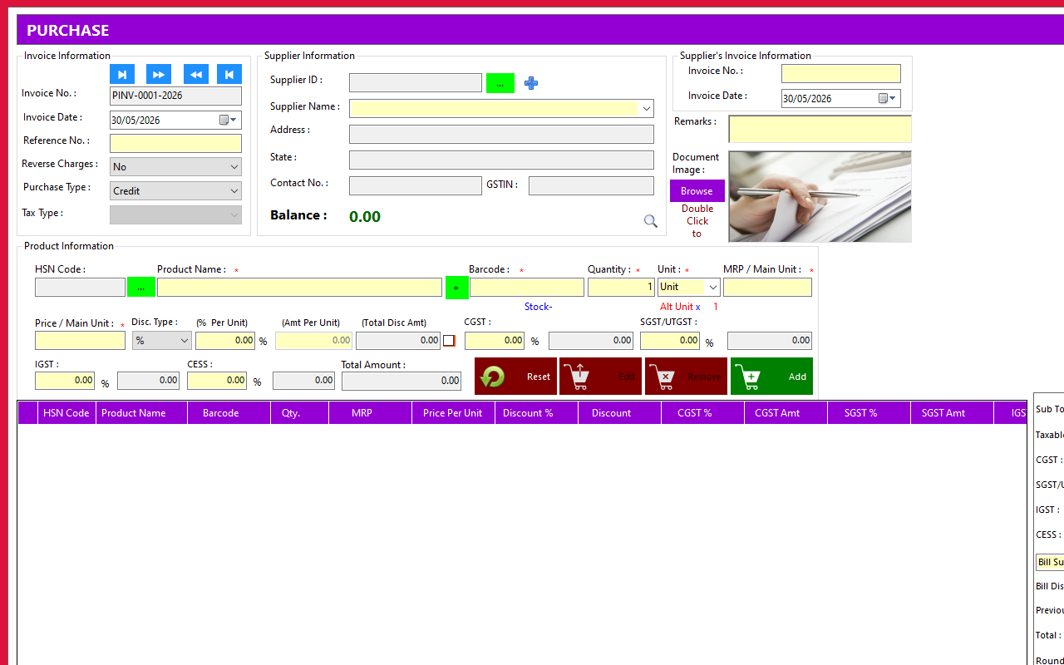
Purchase Entry — supplier, items, GST input and totals
9 Receive a Payment — Receipt (press F3)
Record money received from a customer against their outstanding bills.
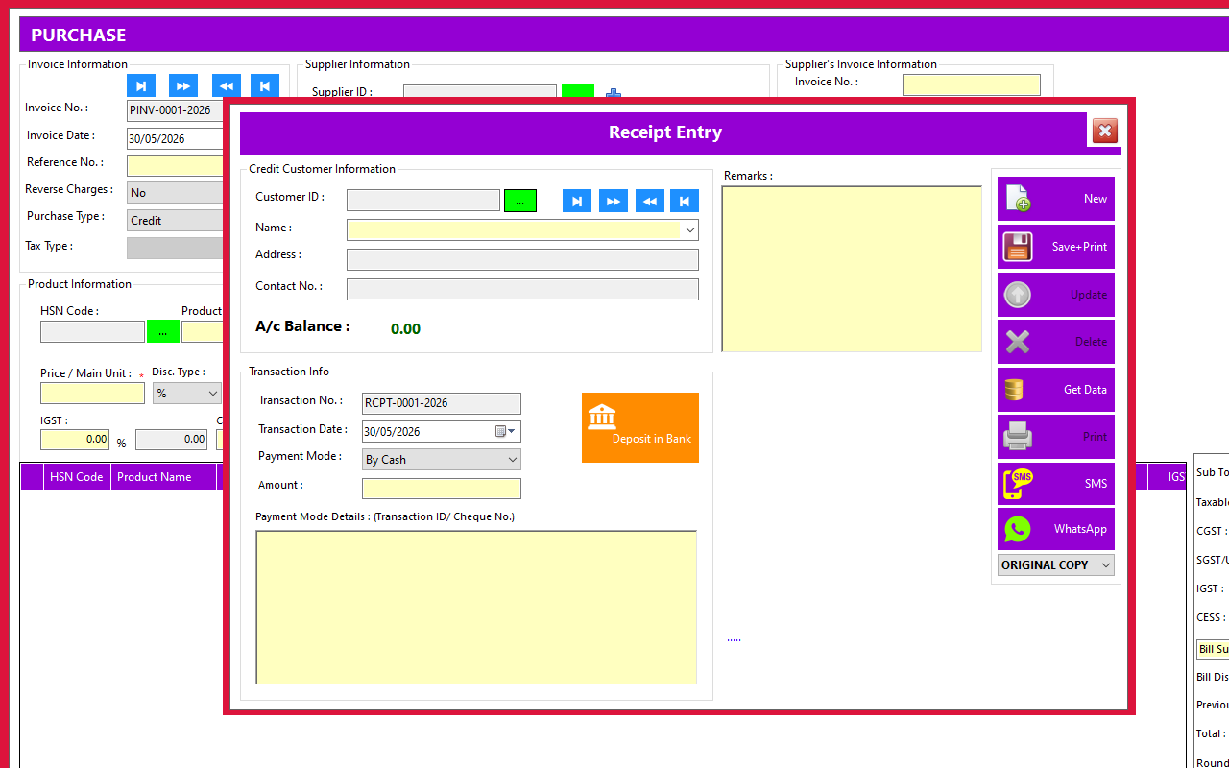
Receipt — record customer payments and clear dues

10 Make a Payment (press F4)
Record money you pay to a supplier. The supplier ledger and cash/bank balance update instantly.
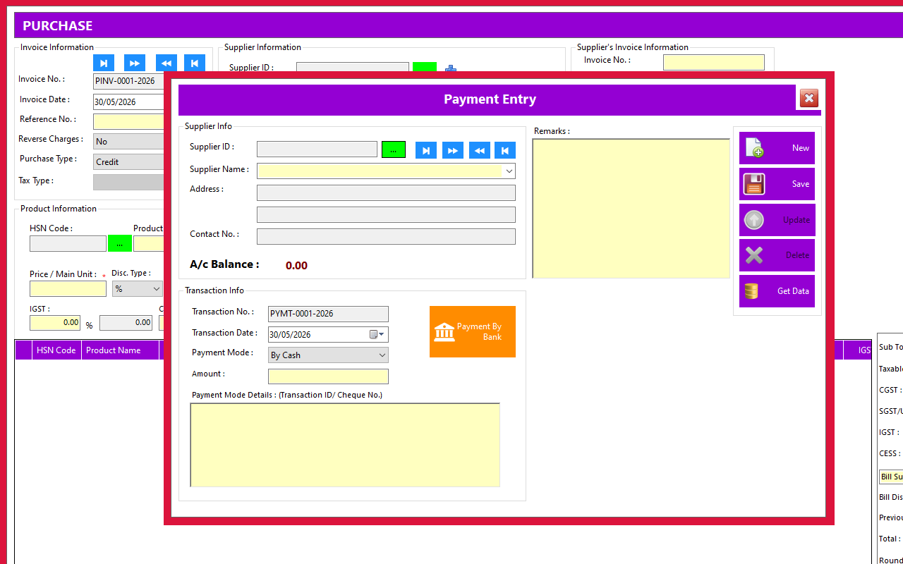
Payment — pay suppliers and track outstanding balances
11 Record an Expense (press F8)
Log day-to-day business expenses (rent, electricity, salaries…) so your profit figures stay accurate.
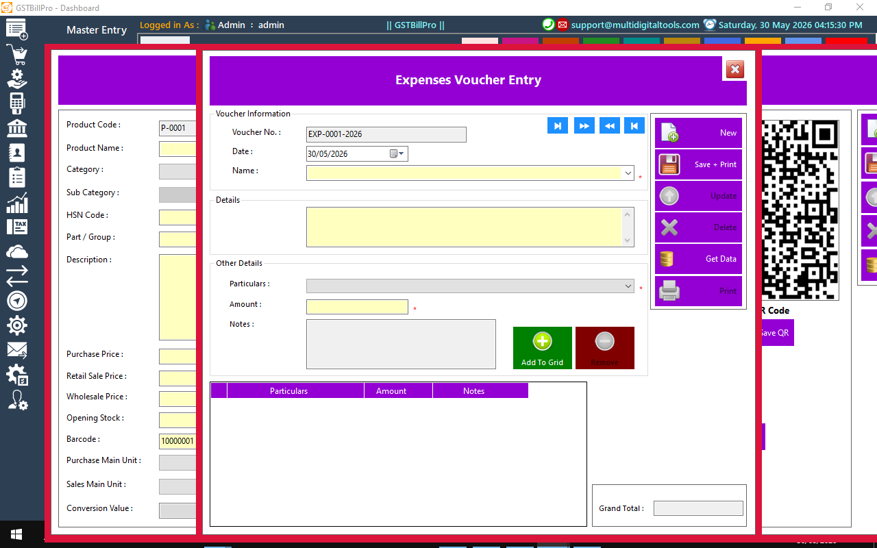
Expense Voucher — capture running costs against expense heads
Reports & GST Returns
Everything you record flows into ready-made reports. Open the Reports and Tax Report menus, or use the Dashboard footer links.
- Business: Sales, Purchase, Stock In Hand, Best/Low-selling items, Salesman commission.
- Accounting: General Ledger, Day Book, Trial Balance, Profit & Loss, Balance Sheet.
- GST compliance: GSTR-1, GSTR-3B, tax summaries and TCS reports.
- Output: Every report can be printed or exported to Excel / PDF.

Settings & Administration
13 Configure the system & manage users
Open the Setting, Database and Administrator menus to tailor GSTBillPro to your business.
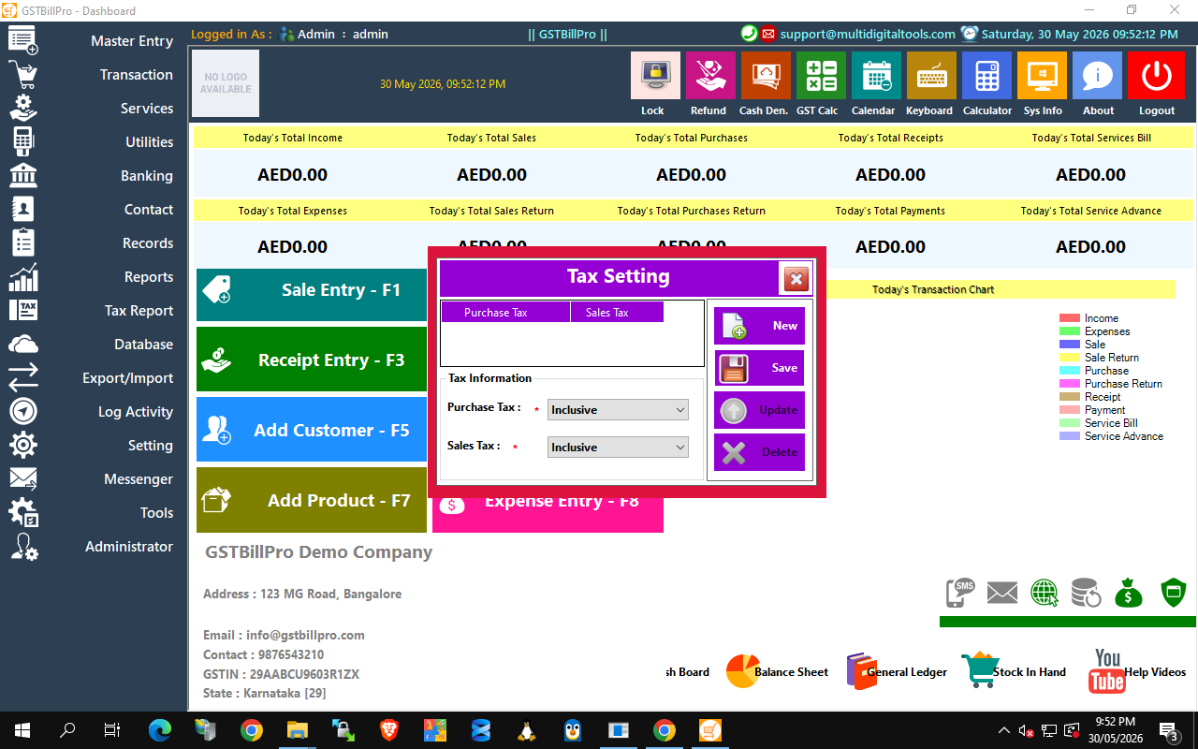
Example: Tax Setting — choose Inclusive / Exclusive tax for purchases & sales
- Tax Setting: set Purchase & Sales tax as Inclusive or Exclusive of GST.
- Company Information: your company name, address, GSTIN, logo and financial year (Master Entry -> Company Information).
- Users & Roles: create staff logins as Admin, Sales Person or Inventory Manager (Administrator -> Users).
- User Permission Settings: switch individual menus/features on or off per user.
- Change Password: each user can update their own password securely (PBKDF2-encrypted).
- Email / SMS Setting: connect your SMTP and SMS gateway to send invoices & alerts.
- Printer / Terminal Setting: pick the invoice printer and POS terminal ID.
- Auto Backup: schedule automatic database backups to protect your data (Database -> Auto Backup).
- Virtual / Multi-Company: create and switch between multiple businesses from one install.
FIRST-TIME SETUP: 1) Company Information 2) Tax Setting 3) Users & permissions 4) Email/SMS & Printer 5) turn on Auto Backup.
Full feature list
- Billing & POS: POS sale, thermal & A4/A5 invoices, barcode scan, hold/unhold, touch grid, loyalty cards, discounts & bill sundry.
- Quotations & Estimates: create, convert to invoice, maintain records.
- Purchase & Stock: purchase entry, purchase orders, stock entry/adjustment, damage/recovery, current stock & in/out reports.
- Returns: sale return (credit note) and purchase return (debit note).
- Services: service creation & service billing.
- Accounting: receipts, payments, income/expense vouchers, cash & bank ledgers, fund transfer/deposit, customer & supplier ledgers, outstanding.
- GST & Tax: CGST/SGST/IGST/CESS, TCS, GSTR-1, GSTR-3B, tax summary.
- Reports: Profit & Loss, Balance Sheet, Trial Balance, General Ledger, Day Book, salesman commission, best/low-selling — print & Excel/PDF export.
- Communication: Email & SMS sender, bulk email/SMS, WhatsApp message, loyalty SMS.
- Data & Admin: multi-company, auto backup, Excel import/export, users & permissions, activity log.
Support & contact
Product page: https://multidigitaltools.com/products/gstbill
Support email: support@multidigitaltools.com
Company: Multi Digital Tools

Good to know
- Shortcuts: Press F1–F8 from the Dashboard for instant access to daily screens.
- Roles: Create staff users under Administrator → Users with per-role permissions.
- Backup: Use Database → Auto Backup to keep data safe — schedule it daily.
- Multi-company: Run several businesses from one install and switch at login.
- Currency: Amounts follow your Windows region — set the PC to India to show the rupee symbol.
Requirements: Windows 10/11/Server (.NET Framework 4.8) · Microsoft SQL Server / Express · report runtime (installed by setup).

© 2026 Multi Digital Tools — https://multidigitaltools.com/products/gstbill — support@multidigitaltools.com

